## **PROJECT TITLE**

## **Bank Management System**

Submitted in partial fulfillment of the requirement of

## PG Diploma in Advanced Computing

**Group 11 Conquerors**

220940520101 Sumit Pal

220940520102 Sumit Singh Thakur

220940520103 Suraj Salunkhe

220940520104 Suresh Kadam

220940520105 Sushil Nikumbh

220940520106 Suyash Dudhawadkar

220940520107 Swastik Awaze

220940520108 Tarun Soni

220940520109 Tushar Gaikwad

220940520110 Vaijesh Manglekar

**Guide(s):**

## Mrs. Nisha Karolia



**Centre for Development of Advanced Computing Kharghar/Juhu**

## September 2022

2

**Contents**

Table of Contents. 2

List of Figures and Tables. 4

1. Introduction. 5
   1. Purpose. 5
   2. Scope of the product. 5
   3. Overview. 5
   4. References. 5
2. Overall Descriptions 7
   1. Product Perspective 7
      1. System Interfaces 7
      2. User Interfaces. 7
      3. Hardware Interfaces. 7
      4. Communication Interfaces. 7
      5. Memory Constraints. 7
      6. Operations. 7
   2. Product Function. 8
      1. User Characteristics 8
      2. Constraints. 8
3. Specific Requirements. 9
   1. External Interfaces. 9
      1. User Interface 9
      2. Hardware Interface 9
      3. Software Interface 9
      4. Communications Interface 9
   2. Functions. 10
   3. Performance Requirements. 13
   4. Logic Database Requirements 13
   5. Design Constraints. 13
   6. Other Requirements. 13

3

1. Software Attributes (Non-functional) 14
   1. Reliability 14
   2. Availability 14
   3. Security 14
   4. Maintainability 14
   5. Portability 15
   6. Requirement Organization. 15
   7. Standard Compliance 15
2. Assumptions/Dependencies. 15
   1. Assumptions. 15
   2. Dependencies 15
3. Appendixes 16
   1. Scenario Diagrams. 16
   2. Requirements Summary 21

**List of Figures and Tables**

Figure 1: Context Diagram. 7

Figure 2: Use Case Diagram 16

Figure 3: Class Diagram 16

Figure 4: E-R Diagram 17

Figure 5: Deployment Diagram… 17

Figure 6: Sequence Diagrams (6) 18

Figure 7: Activity Diagram. 21

**1. Introduction**

This web application must be easy to use and at the same time be sufficiently featuring rich to manage all the site content. It needs to be suitably intuitive for a committed webmaster who wishes to personalize the site.

# Purpose

This document details the software requirements for the Online Banking system project. It defines what the problem is and what problems a complete solution has to solve. The intended audiences for this document are the development team, the team manager, the customer and all other stakeholders in the system.

* 1. **Scope**

New software needs to be built for Online Banking system. For this, a new user should easily be able to get application form, fill that form manually and submit with proof in nearest banks or online. The new user first registers themselves, by applying at the Net Banking site, then fills and submits the form to bank. Finally, the Admin grants the access after verifying the details about new users request and activates the users’ account.

# Overview

Online Banking System project captures activities performed by different roles in real life banking which provides enhanced techniques for maintaining the required information up-to- date, which results in efficiency. The project gives real life understanding of Online Banking System and Activities performed by various roles in the supply chain. New users can register through online application form which is available in our website. After registration the system, it will automatically generate a printout copy, by which they can open a new account in the bank. Online banking services will also be available for all the existing customers.

# References

1. Nancy Day, Software Requirements Specification and Analysis, Lecture 3,

[*http://www.student.cs.uwaterloo.ca/cs445/Fall2005/Schedule/l3.pdf.*](http://www.student.cs.uwaterloo.ca/cs445/Fall2005/Schedule/l3.pdf)

1. Software Engineering Standards Committee of the IEEE Computer Society, IEEE Recommended Practice for Software Requirements Specifications, 1998.
2. Software Requirement Specification (SRS), [*http://se.uwaterloo.ca/dberry/ATRE/srs.pdf.*](http://se.uwaterloo.ca/dberry/ATRE/srs.pdf)
3. Wikipedia, the Free Encyclopedia, [http://en.wikipedia.org/.](http://en.wikipedia.org/)

**2. Overall Descriptions**

The application is to be fully-functional bank software. It will consist of a few different modules:-

The first module is to be a software application that can be used by bank customers Online. This application will allow the user to deposit, withdraw and transfer funds and check balance.

The second module is to be a software application that is used within the bank creates the new user accounts. This application will allow everything the Online allows as well as some additional features.

These features include; account creation, account deletion, customer records, and reports. Both pieces of software will be linked to a central bank server. This server will handle multiple threads and will therefore allow for simultaneous access of multiple users. It will provide for user authentication and will store all data. In these all are handled by Administrator.

# Product Perspective

The Online Banking System is the software, which manages the various users with independent access. The Online Banking is a special order software system. It will be used in the stated configuration of online.

# System Interfaces

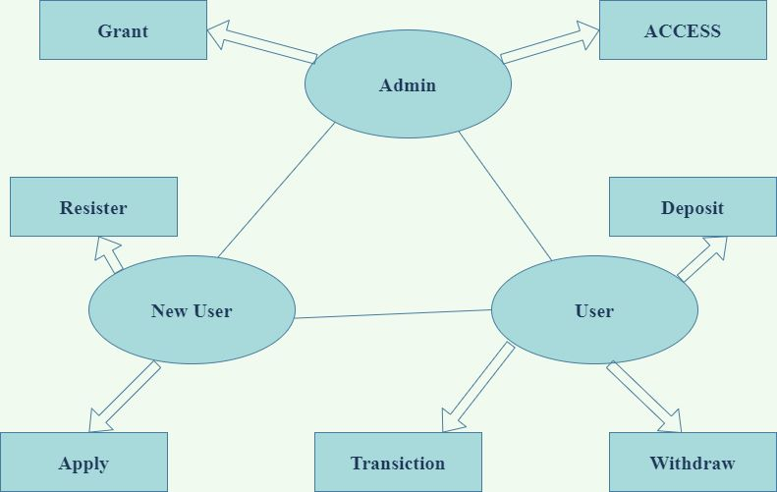

**Figure1: Context Diagram (Online Banking system)**

# User Interfaces

There are four different ways for a user to interact with the system:

**Viewers:** Many unknown persons or un-authenticated persons visit the Bank official site via internet. They collect the information and search what are the schemes are available in the bank web page. Those viewers or visitors became the customer of the bank.

**New User:** Who all visited that Bank webpage or heard about the bank those persons getting ready to start account in bank. They register the bank application form, submit and start account in the nearest bank.

**Existing User:** The Existing user is the most typical user of the Online Banking system. Each Users have their own account and registered or authorized login access. The Existing user can login in online to their account perform the operation of deposit, withdrawn, transfer, balance queries and transactions. All the operation of the banking do in online it helpful for user because save time and efficient process.

**Administrator:** Admin is master user of the system because they are main role of the system. Admin grant and maintain the database of the existing user and grant the permissions to users. It overrules all other users.

# Hardware Interfaces

On each System and internet connections there are processes responsible for it. They perform all online functions needed for a single banking system. If the systems that hardware (server and user’s system) is able to make the banking function properly.

In the server there is a master control panel, which maintains and accesses all the systems as a system customers and bank staffs. This hardware has to work in conjunction with the wire or wireless connections**.**

# Communication Interfaces

The main control of server shall communicate with the customer systems. It shall do so in a safe manner. It can request actions for the online server, but the decision to comply with the request shall remain in the server. Client or customers request the service to (server) admin, who can accept or negate the request and response for that request.

In the event of a communication failure individual systems or connections shall remain functional by the server.

# Memory Constraints

The implementation of the online banking software is constrained by the capabilities of the connections and its application of the software. The master control server in the banking does have the database and user information constraints.

# Operations

Besides the normal behavior of banking related to responding to a browse and request to the servers or admins. New users download the application form of account open and fill that form they submit to nearer branch of same bank. New user can also apply for the online banking access that request send to admin. Admin clarify the details about the user and provide or grant the access for users.

The users can access the service from online banking; authenticated users will perform the operation of login, browsing, deposit, withdrawn, balance query and transactions. An operation of the admin is managing and controls the information and databases.

# Product Function

# User Characteristics

The typical bank customer will be a person, from the age of 18 and up. There will more than likely be a fairly equal distribution of males and females. The typical customer will probably use the online couple of times a week. The typical customer might not know anything about computers, so their system needs to be very simple and easy to use. The typically customer will probably be a busy person; therefore, they will need to do their transactions as quickly and efficiently as possible.

The other user is a bank employee. The bank employee will be a different type of user. The bank Employee is a fairly educated user, who is willing to sacrifice simplicity for functionality. They will use the software daily, for every transaction. This could quite possibly be 30-60 transactions per hour per employee. Due to this frequency of usage stability and speed of this software is incredibly important.

# Constraints

The information of all the users must be stored in a database that is accessible by the Online System.

The Online Banking System is connected and is running all 24 hours a day. The users access the Online System from any computer that has Internet browsing capabilities and an Internet connection. The users must have their correct usernames and passwords to enter into the Online Dictionary System. The project is safety critical. Under no circumstances shall a user of the system be harmed or harm others through proper or improper use of the online. The project shall conform to any rules for Online Banking in place in the United States of America.

**3. Specific Requirements**

# External Interfaces

The external interfaces of the Online Banking system are relative to the various users which contain independent access units in each, and one master control of admin. These interfaces are described below:

# User Interface

The User Interface defines the human-computer interaction of the Online Banking system. The system requires interaction from various users:

* The standard existing users or customers interact with the online interface within the banking System.
* The existing user interacts with the system to allow or authenticate for deposit, withdrawn, transfer and balance queries
* The new user interacts with the system to register and apply to the Online Banking transactions.
* The Administrator interacts with the system within the master control unit. These people are given special preference privileges (usually reserved for maintenance crew or building databases) and manage all type of users.

# Hardware Interface

The software shall interface with the electromechanical that controls the online connection systems. The software shall interface with a breaking mechanism in case of emergencies. The transactions and accesses shall be controlled by the software based on command and graphical user inputs. The hardware interface is supported by the main control panels (buttons, keyboard, mouse and communication mediums).

# Software Interface

Software interface is supported by the main control panels and operating system in which hosts the algorithms for calculating distributed travel and wait time information.

Additionally, the algorithms define and export system commands for main control panels, and communication mediums. For testing purposes the software shall be capable of interfacing with software simulators on a PC computer using GUI applications of webpages.

# Communications Interface

All system interfaces communicate in order to activate ordered requests. The communication mediums (wired or wireless) are the external interface that communicates with the control panel of the Online Banking System. This communication allows for failure messages, and requests to be sent and received by the main system.

# Functions

The Online Banking System shall contain the following functionality organized by object:

* + 1. **.Logon Capabilities**

INPUT- The username and password

OUTPUT- the personalized login page will be displayed.

PRECONDITION – the user should be a registered customer/ should register as a new user. POSTCONDITION- NA.

It is basically the login page through which user interacts with the Banking site. It has various functions. Users can enter into his/her account where a personalized view is available. His most common searches and the recent updates can be viewed because his details and his activities would be updated, on every logon, in the user database.

New users could also use services like deposit, withdraw and other applications after registering on the site. There is a link provided on the new link to register, if a new user. User can also give balance enquired to the login page.

Various links like home, register, about are available to go directly to the page desired. User can contact admin or can check for validation of site. User can directly go to login section, check for new updates etc. through this page. User can also go directly to the searched as link series is given there in login page itself. So, just by clicking on the link, user will be able to see the pages what he/she want from banking services.

* + 1. **Browsing**

INPUT- Clicks on the link to which the service belongs. OUTPUT- The service of the banking web page view

PRECONDITION- The link pages should exist in the banking database. POSTCONDITION- NA.

The Online Banking can be providing the services to customers. The browsing links are given in a section in the footer region and it will be replicated in all the html sheets, thus the accessibility is high. The browsing functionality is simple. The links are arranged service vice and each of them is links. When the user clicks on the service links which gets highlighted on hovering, and the section showing the various pages in the database related to the specified letter is shown on the web pages. These pages are generated dynamically on accessing the banking database. These links generated are also hyperlinks, which on clicking leads the user to a page with all the details relating to the page, from service usage, messages and related page links to service and its origins. This makes an ease access and is supposed to give a feel of the quick transaction banking system.

* + 1. **Register**

INPUT - New user fill the details send the completed form OUTPUT - The form is sent to the administrator.

PRECONDITION – the user should be a registered customer/ should register as a new user. POSTCONDITION- NA.

The new users like star the account in the bank they directly download application form from banking webpage. Hereafter download the application form fill and approach to start account in nearer that bank. New users want to start the online banking services they fill the form in online and send to admin. Admin verified that details and provide the service to users.

* + 1. **Print view**

INPUT - New user download the completed form OUTPUT - the form is view and make ready to print

PRECONDITION – User download the application form from webpage POSTCONDITION- NA.

New user can download application form and fill that. It needs to start account in the bank. User will submit all their information for bank verification.

* + 1. **Money Deposit**

INPUT - User can click the link and send to database OUTPUT - user can view the information in page PRECONDITION – the user should be a deposited their account. POSTCONDITION- NA.

Existing users deposit the money from directly or transfer from any other bank/ same bank different accounts. The deposit amount is credited in user account that amount updated in database.

* + 1. **Money Transfer**

INPUT - User can click the link and send to database OUTPUT - user can view the information in page PRECONDITION – The user click the hyperlink in webpage. POSTCONDITION- User views the balance amount in page.

Existing users withdraw or transfer the money from directly or transfer to any other bank account/ same bank different accounts. The withdrawn amount is detected in user account that amount updated in database.

* + 1. **Account Information**

INPUT - User can click the link and send to database OUTPUT – User can view the information in page PRECONDITION – the user click the hyperlink in webpage. POSTCONDITION- User views the balance amount in page.

Users enquire about their balance amount and bank provides the facility to user see the latest five transaction of that month and interest of balance amount.

* + 1. **Session count**

INPUT - NA

OUTPUT – User can view the count the login various timings on the day. PRECONDITION – NA

POSTCONDITION- User can view the information in page.

Bank provides this type of facility to user self-verification of their login actions. It is using security purpose user know the counts of login. If Unauthenticated people if enter into the users login user know the login sessions and retrieve the users details easily.

* + 1. **News flashes**

INPUT - NA

OUTPUT - The page displays the news articles. PRECONDITION – NA

POSTCONDITION- the user should be a view/read the new flashes

There are many news articles which find relevance on a site, with news relating to the world of Banking and purchasing .Since this is not a traditional Banking, it’s not supposed to be looking like one too. Thus we have a special facility, in which some news snippets would be added. These would either be pictorially arranged or by some links to lead the user to the parent site. The news articles may be on the various messages, articles and contents, their view points or on some recent news in the field of arts.

* + 1. **Feedback**

INPUT - Username and password to send the completed form OUTPUT - The form is sent to the administrator.

PRECONDITION – The user fill the form send to admin. POSTCONDITION- NA.

Various systems require regular feedback mechanisms to know about the various mistakes which the system would be making. Thus if the users have any grievances they wish to share, they could either fill a form on the feedback page or just give suggestions in the text box provided. Moreover it is an open site and many users could apply for the position of contributors and could help in the development of the system. The suggestions provided would be useful in evaluating the system, its working and its effectiveness.

* + 1. **Quote of Services Schemes**

INPUT - NA

OUTPUT- the random quote of the Schemes will be published every day. PRECONDITION–NA

POSTCONDITION–the user should be a view/read the quote

Like the word of the Schemes tool, we described earlier, we have another tool known as the quote of the Schemes. It’s a random quote generator function which not only quotes the words of Latest services or offers, but also gives references to the personalities and also to the situations in which it were used.

# Performance Requirements

The Online Banking System shall be built upon an internet connection of server. The processor must be capable of handling real-time functionality activated by the defined users and communication medium. In addition, the system must be safety-critical. All failures reported by the communication medium must be handled instantaneously to allow for user and system safety.

The software shall control n-user in a building with m-services. The maximum number of commands the software shall handle is (m*n) +2*(m-1) +n, where m is the number of services and n is the number of users. The software shall have a communication time variable of x seconds, based on signal or web based inputs, which if exceeded, the software shall recognize an error and take corrective action

# Logic Database Requirements

A one-to-many relational database shall be used in order to validate various user requests and failure types. Moreover, failures are to be logged for reference. The database shall be concurrent with the performance requirements of the Online Banking System.

# Design Constraints

The Online Banking System shall run on an embedded system that handles safety-critical functionality. The system shall use a real-time processor with dynamic memory allocation in order to handle continuous activity. Also, user and software interfaces shall be simple and user- friendly, and comply with the following:

**Standards Compliance:** The software shall adhere to Account Department codes and regulations, and Building codes related to public accounts safety.

**Hardware Limitations:** This software shall run only on an internet, it must be easily transferable to the field. Admin perform the operation in online either offline.

# Other Requirements

A degraded mode of operation should be possible in which each user can operate independently of central scheduling. The software shall have power failure and error recognition codes acting as a safety net, thus keeping the software from performing any major catastrophic functions.

In the next stage it is to be decided that which medium is the most appropriate for the output. The main considerations when deciding about the output media are:

* The suitability for the device to the particular application.
* The need for a hard copy.
* The response time required.
* The location of the users
* The software and hardware available.

Keeping in view the above description the project is to have outputs mainly coming under the category of internal outputs. The main outputs desired according to the requirement specification are:

The outputs were needed to be generated as a hot copy and as well as queries to be viewed on the screen. Keeping in view these outputs, the format for the output is taken from the outputs, which are currently being obtained after manual processing. The standard printer is to be used as output media for hard copies.

**4.1. Usability**

**4. Software Attributes (Non-functional)**

The users of the system are members and the administrators who maintain the system. The members are assumed to have basic knowledge of the computers and Internet browsing. The administrators of the system to have more knowledge of the internals of the system and is able to rectify the small problems that may arise due to disk crashes, power failures and other catastrophes to maintain the system. The proper user interface, user’s manual, online help and the guide to use and maintain the system must be sufficient to educate the users on how to use the system without any problems.

# Reliability

The system is safety critical. If it moves out of normal operation mode, the requirement to drop to the next lower floor and open its doors is given priority. This emergency behavior shall not occur without reason. The system has to be very reliable due to the importance of data and the damages incorrect or incomplete data can do.

* 1. **Availability**

When in normal operating conditions, request by a user for an servicer shall be handled within 1 second. Immediate feedback of the systems activities shall be communicated to the user by link page clicked.

At peek system load, individual users at either the server in the security office, at the links or inside the banking system shall not experience any delay in the service response to their commands longer than 1 second. **:** The system is available 100% for the user and is used 24 hrs. A day and 365 days a year. The system shall be operational 24 hours a day and 7 days a week.

* 1. **Security**

There shall be no security mechanisms in place to keep unwanted users out of the system. However, all users of the system shall not be able to perform actions or request actions from the Banking system, which will cause harm to any person or damage to the system or its environment.

* 1. **Maintainability**

There shall be design documents describing the internal works of the software. There shall be an access on the control panel and servers for the purpose of upgrading the software or flashing any firmware.

* 1. **Portability**

There are no portability requirements.

Requirement Organization: All requirements shall be organized according to object. First general requirements for all service types shall be described. Following are sections for each service type and their special requirements. Last are requirements related to other objects like the users view pages and any other.

* 1. **Standard Compliance**

The Banking systems hardware and software shall be built according to the 2008 standard for Online Banking systems issued by the government of the United States of America.

* 1. **Mean Time between Failures (MTBF)**

The system will be developed in such a way that it **may** fail once in a year.

* 1. **Mean Time to Repair (MTTR)**

Even if the system fails, the system will be recovered back up within an hour or less.

* 1. **Accuracy**

The accuracy of the system is limited by the accuracy of the speed at which the employees and users use the system.

* 1. **Maximum Bugs or Defect Rate**

Not specified.

* 1. **Access Reliability**

The system shall provide 100% access reliability.

**5. Assumptions/Dependencies**

* 1. **Assumptions**

Embedded real-time environment, or compatible, available on platform if the client changes or upgrades their office system, the Online Banking System will not be guaranteed to function unless the new operating system is fully compatible with the current system as described in section 3 of this document. All timings stated in this SRS shall be adhered to within +/- 10% all requirements are addressed in this version of the Online Banking System. No requirements are delayed to future versions.

* 1. **Dependencies**

The various numbers of users and services on the Online Banking system

* Power source
* Systems(User systems/Servers)
* Communication mediums(wired/wireless)
* Internet Connections

**6. Appendixes**

* 1. **Scenario Diagrams**



New User

Create UID

Register

Admin

Login

Existing User

Browse

Deposit

Withdraw

Purchase

Enquire

**Figure2: Use-Case Diagram**

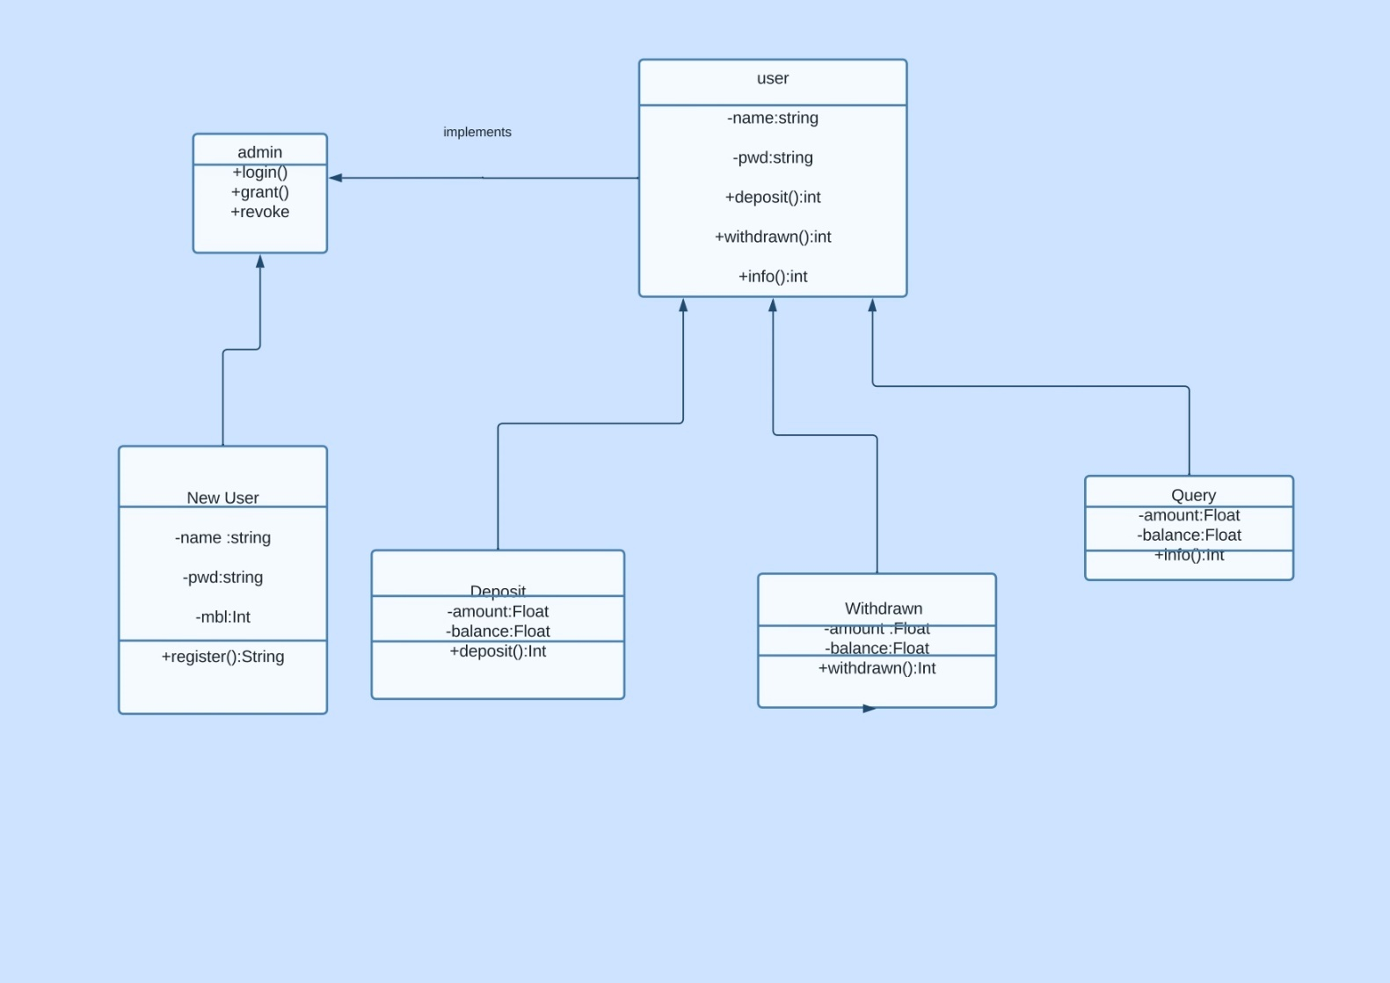

**Figure3: Class Diagram**

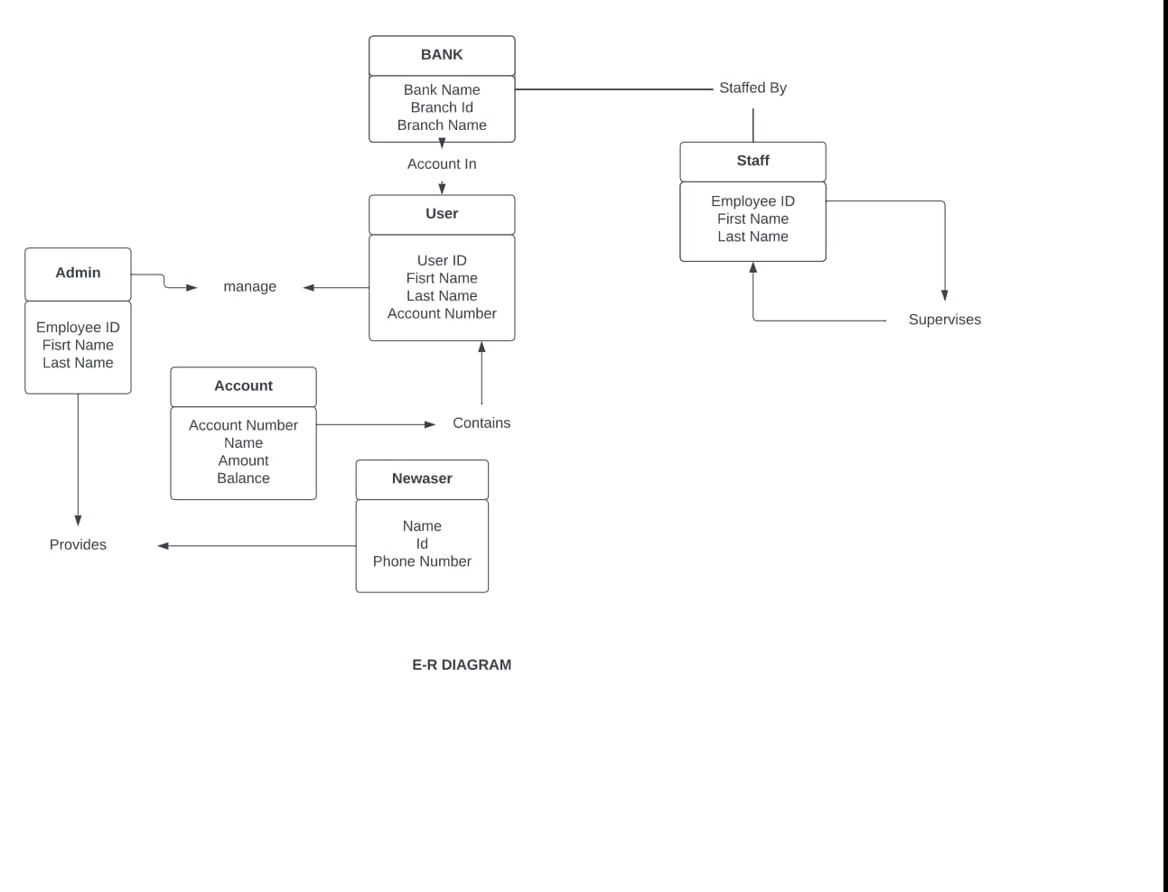

**Figure4: E-R Diagram**

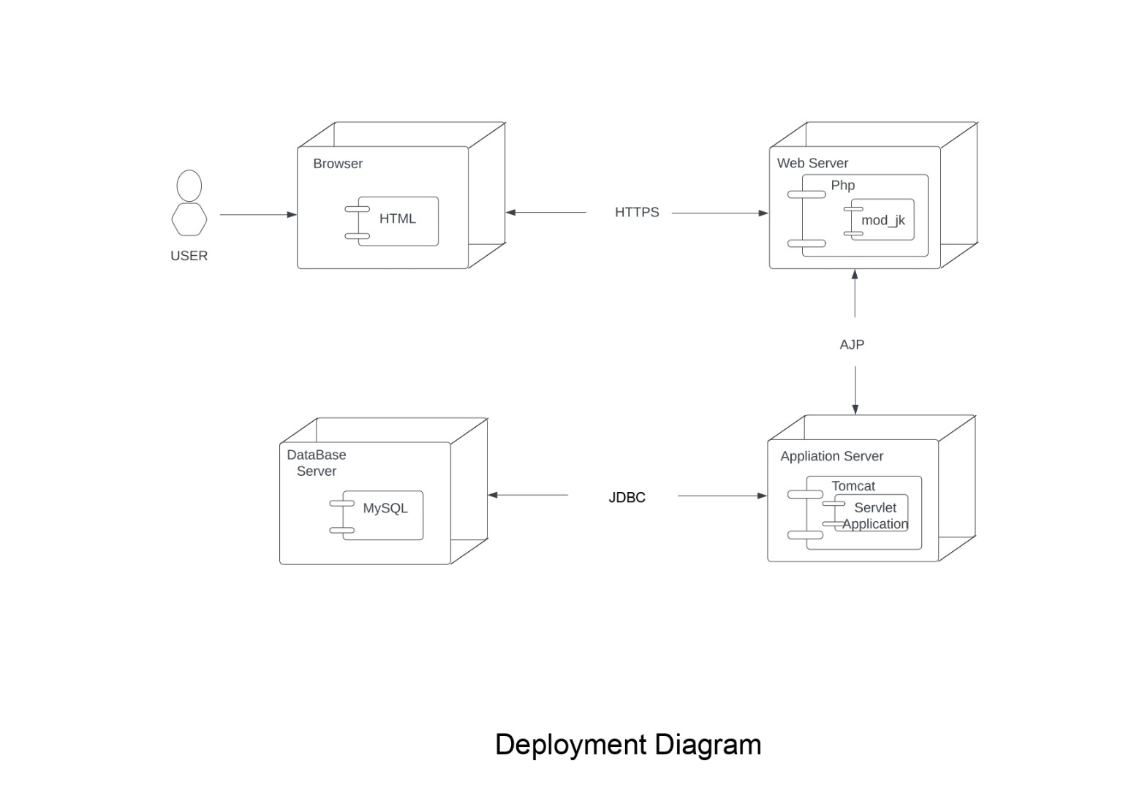

**Figure5: Deployment Diagram**

Welcome Screen

User Object

main login window

Online System

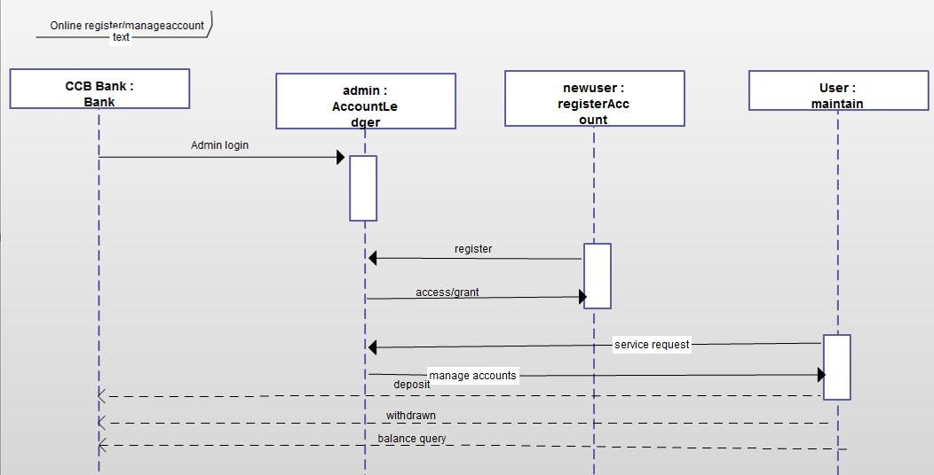

Authenticate Sequence Diagram

User Object

Welcome Screen

main login window

Online System

1: open window

2: Username

3: Password

4: Validated

5: Open window

open window

Another Transaction window

Deposit window

Online account

User account

User Object

Check balance

Other transact...

yes:Open window

Online system

Deposit Sequence Diagram

open window

Another Transaction window

Deposit window

Online account

User account

1: open window

2: Deposit amount 3: User account

4: Set update user balance

5: NO: return to login

6: yes:return to main screen

Balance query Sequence Diagram

User Object

Check balance

Other transact...

yes:Open window

Online system

1: open window

2: View balance

3: yes : open window

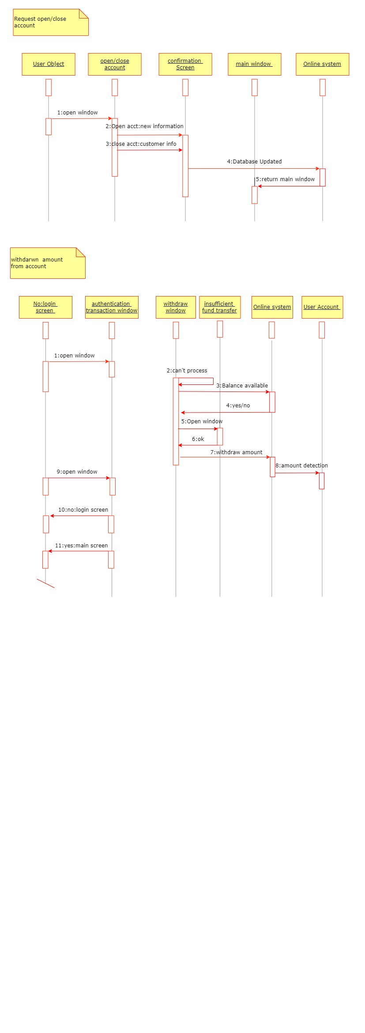

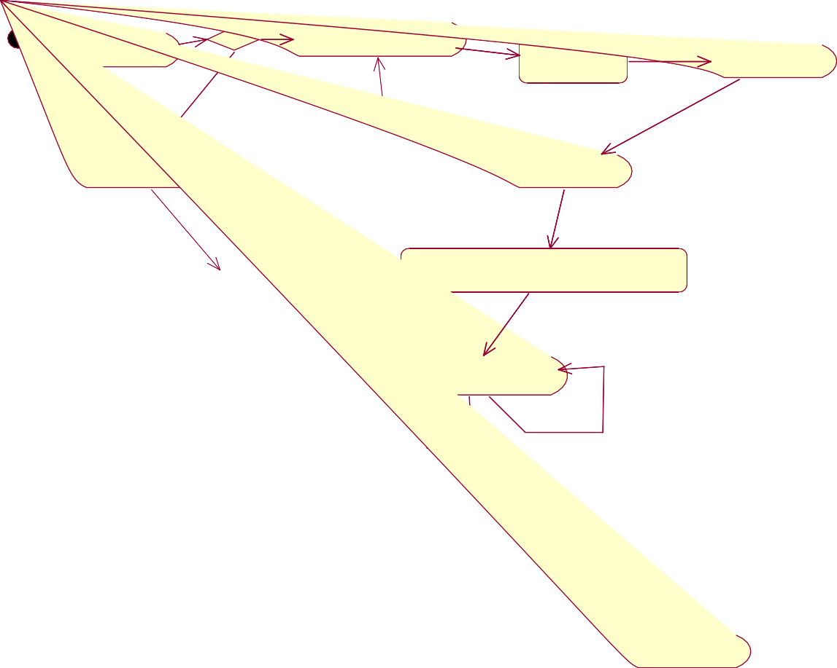

Open Home page

Existing User

Login using Username

and Password

Login page for User

Search Services

New User

Authenticated User

Register in the Login site

Search Link

Admin accepted

Page with deposit,withdraw,balance enquiery,feedback

Click whatever optin you want

Account Transfer

Withdraw

DeposiT

Balance Enquiery

Feed back

End session

Logout

YES

*Success*

NO

Goto main menu

**Figure7: Activity Diagram**

* 1. **Requirements Summary**

System analysis will be performed to determine if it is feasible to design information based on policies and plans of the organization and on user requirements and to eliminate the weaknesses of the present system.

General requirements are: -

* + 1. The new system should be cost effective.
    2. To augment management, improve productivity and services.
    3. To enhance User/System interface.
    4. To improve information qualify and usability.
    5. To upgrade system’s reliability, availability, flexibility and growth potential.